RA 26-221

CORRECTIONS DEPARTMENT[201]
Regulatory Analysis
Notice of Intended Action to be published: 201—Chapter 1
“Departmental Organization and Procedures”

Iowa Code section(s) or chapter(s) authorizing rulemaking: 904.103
State or federal law(s) implemented by the rulemaking: Iowa Code chapter 904

Public Hearing
A public hearing at which persons may present their views orally or in writing will be held as follows:
September 8, 2026  10:30 to 11:30 a.m. | Via Google Meet  meet.google.com/ikd-tecb-vuh  Or dial: 1.317.469.9645  PIN: ‪984 771 251#
Public Comment
Any interested person may submit written or oral comments concerning this Regulatory Analysis, which must be received by the Department of Corrections no later than 4:30 p.m. on the date of the public hearing. Comments should be directed to:
Jen Rathje
Iowa Department of Corrections
Jessie Parker State Office Building
510 East 12th Street
Des Moines, Iowa 50319
Phone: 515.802.0898
Email: jen.rathje1@iowa.gov
Purpose and Summary
This proposed rulemaking rescinds and replaces Chapter 1 with revised administrative rules to satisfy the requirements of Executive Order 10. The purpose of Chapter 1 is to provide the public with a clear, accessible overview of the Department’s organizational structure, mission, and central contact protocols.
Pursuant to Executive Order 10, the Department conducted a comprehensive review of this chapter to eliminate restrictive terms, obsolete rules, and language that duplicates State statutes. Specifically, this rulemaking:
● Updates the description of the Board of Corrections to align its function with the statutory changes mandated by 2024 Iowa Acts, chapter 1182 (House File 2686).
● Consolidates and streamlines public contact paths.
● Deletes granular internal staff responsibilities and specific facility contact metrics that are more accurately maintained on the Department’s active website, thereby preventing the rules from becoming instantly obsolete.
● Eliminates redundant text regarding topics that are already comprehensively governed by Iowa Code chapters 21 and 904.
The result is a streamlined chapter that maintains essential public transparency while ensuring alignment with provisions of the Iowa Code.
Analysis of Impact

1. Persons affected by the proposed rulemaking:
● Classes of persons that will bear the costs of the proposed rulemaking:
No classes of persons will bear any costs from this proposed rulemaking.

● Classes of persons that will benefit from the proposed rulemaking:
The general public, Department stakeholders, and individuals interacting with the Department will benefit from the increased clarity, streamlined communication channels, and updated statutory references provided by this proposed rulemaking.

2. Impact of the proposed rulemaking, economic or otherwise, including the nature and amount of all the different kinds of costs that would be incurred:
● Quantitative description of impact:
There is no known quantitative or financial impact.

● Qualitative description of impact:
There is no known qualitative impact.

3. Costs to the State:
● Implementation and enforcement costs borne by the agency or any other agency:
There are no additional implementation or enforcement costs borne by the Department or any other agency because these updates align administrative rules with current agency practices.

● Anticipated effect on State revenues:
There is no effect on State revenues.

4. Comparison of the costs and benefits of the proposed rulemaking to the costs and benefits of inaction:
The benefit of the proposed rulemaking is an accurate, streamlined, and legally compliant chapter that satisfies Executive Order 10 at no additional cost. Inaction is not permissible.

5. Determination whether less costly methods or less intrusive methods exist for achieving the purpose of the proposed rulemaking:
No less costly or less intrusive methods exist. Rulemaking is the legally required method to maintain an administrative framework that complies with the Iowa Code and the mandates of Executive Order 10.

6. Alternative methods considered by the agency:
● Description of any alternative methods that were seriously considered by the agency:
No alternative methods were considered.

● Reasons why alternative methods were rejected in favor of the proposed rulemaking:
Alternative methods were not considered because formal rulemaking is required to bring the chapter into compliance with Executive Order 10 directives.

Small Business Impact
If the rulemaking will have a substantial impact on small business, include a discussion of whether it would be feasible and practicable to do any of the following to reduce the impact of the rulemaking on small business:
● Establish less stringent compliance or reporting requirements in the rulemaking for small business.
● Establish less stringent schedules or deadlines in the rulemaking for compliance or reporting requirements for small business.
● Consolidate or simplify the rulemaking’s compliance or reporting requirements for small business.
● Establish performance standards to replace design or operational standards in the rulemaking for small business.
● Exempt small business from any or all requirements of the rulemaking.

If legal and feasible, how does the rulemaking use a method discussed above to reduce the substantial impact on small business?
This proposed rulemaking has no impact on small business.
Text of Proposed Rulemaking
ITEM 1. Rescind 201—Chapter 1 and adopt the following new chapter in lieu thereof:

TITLE I
GENERAL DEPARTMENTAL PROCEDURES
CHAPTER 1
DEPARTMENTAL ORGANIZATION AND PROCEDURES
201—1.1(904) Title I definitions.
“Department” means the department of corrections.
“Director” means the director of the department of corrections.
“District department” means the same as defined in Iowa Code section 904.101(7).
201—1.2(904) Mission and function.
1.2(1) The department is established by Iowa Code chapter 904 and consists of an advisory board, a director and areas of responsibility.
1.2(2) The mission of the department is creating opportunities for safer communities.
201—1.3(904) Offices.
1.3(1) Central office. The central office for the department is located in the Jessie Parker State Office Building in the Capitol Complex in Des Moines. Its mailing address is the Department of Corrections, Jessie Parker State Office Building, 510 East 12th Street, Des Moines, Iowa 50319.
1.3(2) Contact information. Contact information for correctional institutions, district departments and other offices located outside the principal headquarters may be found on the department’s website at doc.iowa.gov. The following map provides a general overview of district department and correctional institution locations.
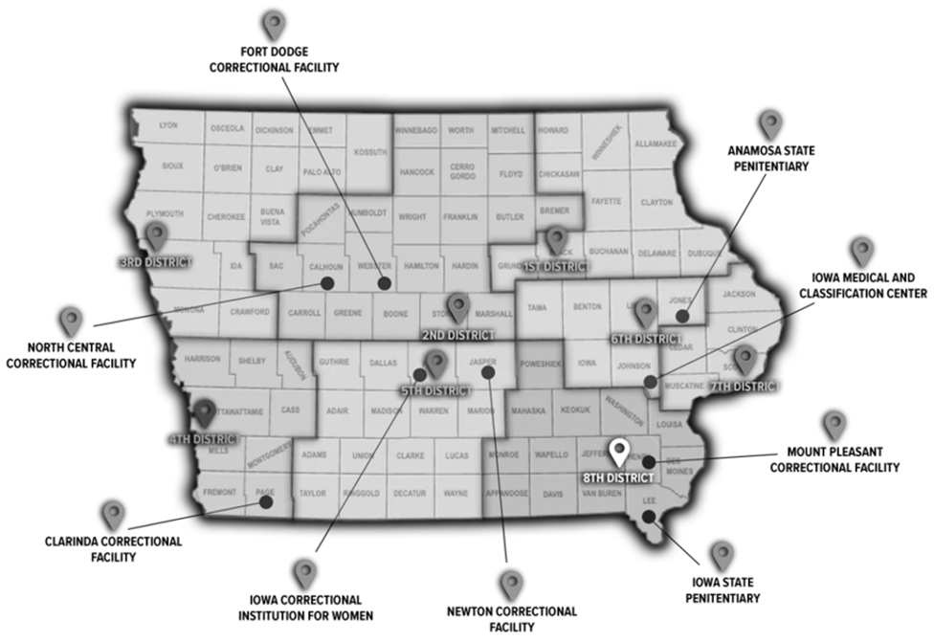
201—1.4(904) Public contact information.
1.4(1) Information regarding department offices and methods for contacting the department are available on the department’s website.
1.4(2) Public records requests shall be submitted in accordance with 201—Chapter 2505.
201—1.5(904) Board of corrections.
1.5(1) The director of the department has, by statute, the advice and counsel of the board of corrections. This seven-member board is appointed by the governor with confirmation by the senate, and its powers and duties are advisory with respect to the services and programs operated by the department.
1.5(2) The board will oversee the work of the department as defined in Iowa Code section 904.105 and, for this purpose, will have access at any time to all books, papers, documents, and records of the department.
1.5(3) Meetings of the board and any committees appointed by the chairperson will be conducted in accordance with Iowa Code chapter 21. The chairperson may appoint committees as necessary to conduct the business of the board.
1.5(4) A quorum shall consist of two-thirds of the membership appointed and qualified to vote.
1.5(5) When a quorum is present, a position is carried by a majority of the qualified members of the board.
1.5(6) Persons wishing to appear before the board shall submit their request to the department office not less than ten days prior to the meeting. Presentations may be made at the discretion of the chairperson and only upon matters appearing on the agenda.
1.5(7) Persons wishing to submit written material should do so at least ten days in advance of the scheduled meeting to ensure that board members have adequate time to receive and evaluate the material.
201—1.6(904) Director.
1.6(1) The governor appoints the director of the department. The director is responsible for the daily administration of the department.
1.6(2) The appointment, qualifications, and duties of the director are mandated in Iowa Code sections 904.107 and 904.108 and other applicable provisions of the Iowa Code.
201—1.7(904) Organization of the department. The department is established by Iowa Code section 904.102 to perform the functions and duties set forth in that section, in Iowa Code section 904.103, in other applicable provisions of the Iowa Code, and in the Iowa Administrative Code.
These rules are intended to implement Iowa Code sections 904.101 through 904.108.

